**Project Name:** Python Sinhala

**Used Technologies:** Android Studio, Java, HTML , Bootstrap

**Description:** An android application that helps people to startup with programming. It has over 5000 downloads through the Google Playstore.

**Project URL :** play.google.com/store/apps/details?id=bevylabs.buddhika.pythonsinhala

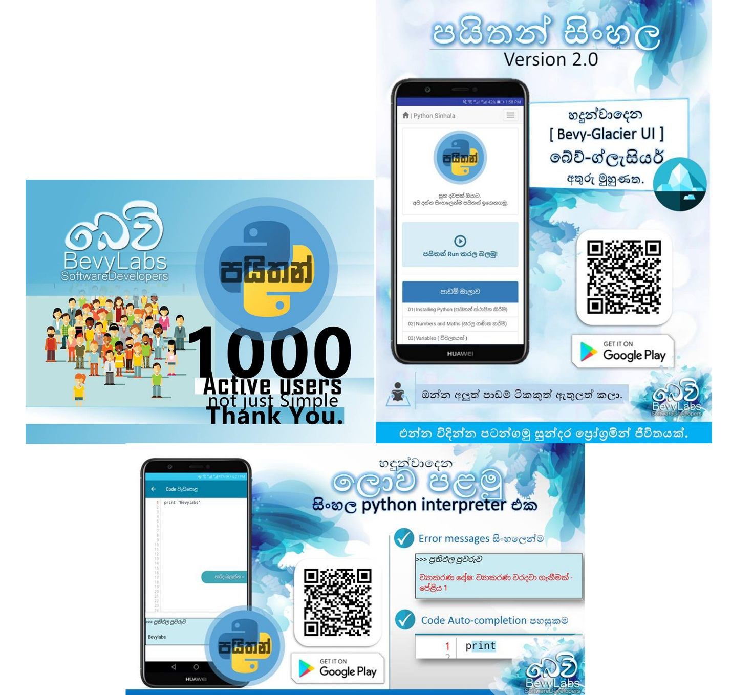

**Project Name:** “Amba Yaluwa” – The Concentration Device

**Used Technologies:** Arduino ,NodeMCU, C , Electronics

**Description:** A concentration device that based on psychology techniques (Color psychology , Pomodoro technique)

**Project URL :** 3rd Place ( Bronze Medal ) in Applied Science & Technology “Sahasak Nimeum” National Exhibition and Competition 2018 An Exhibition Organized by Sri Lanka Inventors Commission.

Merit Award - National Best Quality ICT Awards (NBQSA) 2018 Organized by British Computer Society (BCS) – The Chartered Institute for IT.

Finalist IEEE SS12 MakerFair South Asian Exhibition and Competition 2018 An innovations exhibition Organized by IEEE

**Project Name:** NoteReview App

**Used Technologies:** Android Studio, Java, GoogleVisionAPI

**Description:** A solution for review notes and can evaluate the user in less than in 2mins.

**Project URL :** play.google.com/store/apps/details?id=com.bevylabs.buddhika.notereview

**Awards :** Gold Medal - IPITEx 2019 (International Exhibition and Competition ) Bangkok International Intellectual Property Invention, Innovation and Technology Exposition.

1st Place ( Gold Medal ) in ICT Category “Sahasak Nimeum” National Exhibition and Competition 2018 An Exhibition Organized by Sri Lanka Inventors Commission

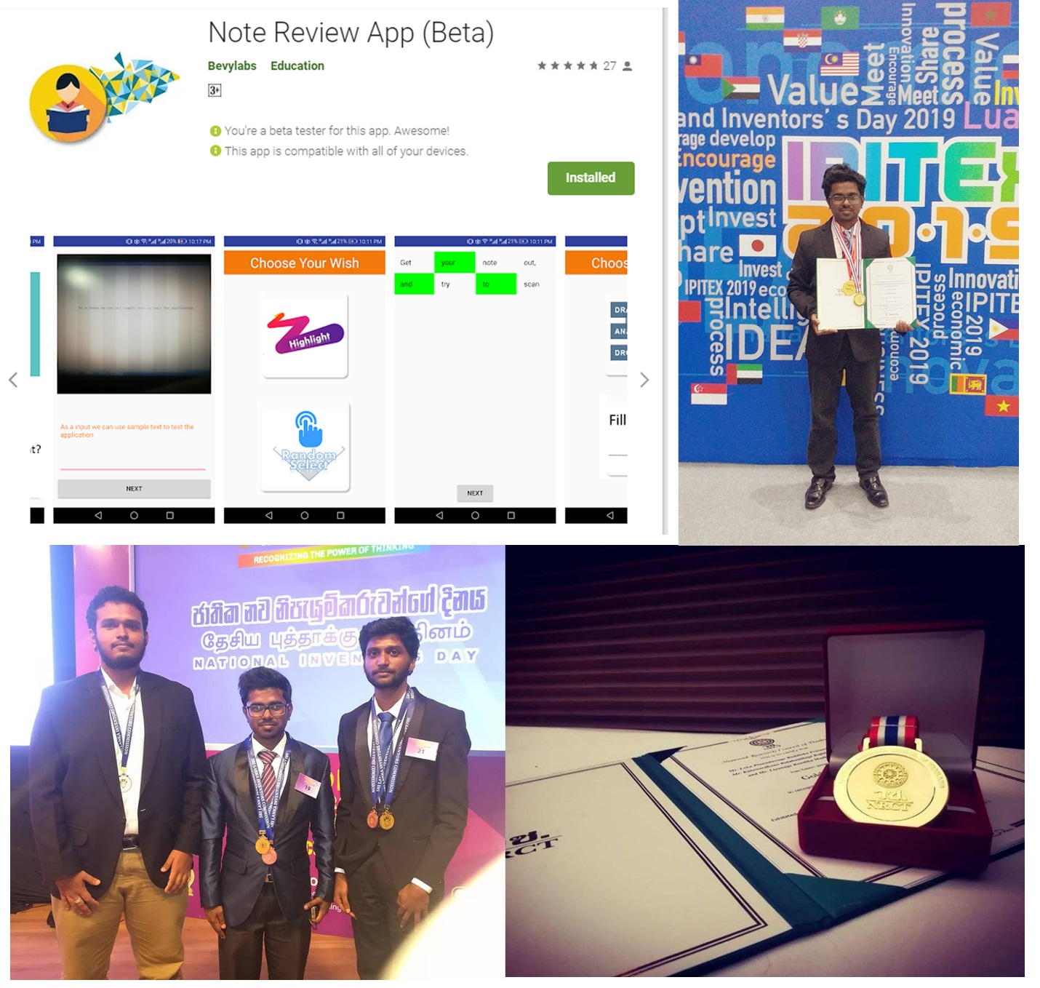

**Project Name:** Hithumathe Jeevithe – The Android Game

**Used Technologies:** Unity, Adobe PS, Autodesk SB, FL-Studio.

**Description:** Sri Lanka’s first game with a rap music. A platformer action game.

**Project URL :** play.google.com/store/apps/details?id=com.BevyLabs.Hethumathe

**Awards :** 1 st place UWU GameJam 2018 A Game Hackathon Organized by Mozilla Campus Club - UWU.

**Project Name:** “BevyLabsFlyBee”

**Used Technologies:** Linux kernel, Python, OpenCV, Processing

**Description:** An autonomous drone that can fly using detecting lines.

**Project URL :**

**Project Name:** Project “GenACMS”

**Used Technologies:** Arduino, C, Electronics, MSExcel.

**Description:** A solution for measuring/indicating A/C voltages levels with real-time monitoring system.

**Project URL :**

**Project Name:** Project “Vibes”

**Used Technologies :** Android, Firebase, GoogleVisionAPI, MSExcel

**Description :** A mobile solution for who want to mark attendance of a large number of people in less amount of time.

**Project URL :**

**Project Name:**

**Used Technologies :**

**Description :**

**Project URL :**

**Project Name:**

**Used Technologies :**

**Description :**

**Project URL :**

**Project Name:**

**Used Technologies :**

**Description :**

**Project URL :**